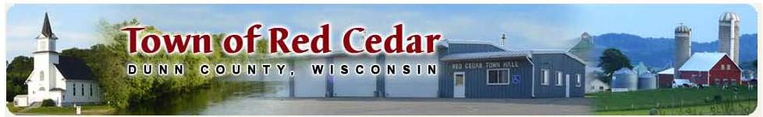
June 2020
Due to proposed changes in the Dunn County Solid Waste and Recycling Program, which will negatively affect our residents, the Town of Red Cedar is looking into other options. Your Town Board encourages you to go online and complete the survey, it should take only two minutes, and to attend the Town Board meeting on July 13th at 6:30 pm for an informational meeting.
In November 2019, the Dunn County Solid Waste and Recycling Department (DCSW&RD) held a special meeting to discuss a Proposed Alternative Solid Waste and Recycling Business Model. At this meeting, it was proposed to increase fees to the towns to help balance the budget, at the same time they would stop recycling select items that are not mandated to be recycled by the State of Wisconsin. Since towns had already passed their local budgets, based on numbers provided by DCSW&RD, and prepared documents for their residents, the Dunn County Solid Waste and Recycling Management Board (DCSW&RMB) decided to leave the amount charged to towns the same. This action resulted in a deficit for 2020.
Fast forward to the spring of 2020, the DCSW&RMB started to discuss the deficit and how they would overcome it. DCSW&RMB recommended borrowing $330,000 from the County general fund to cover expenses through the end of the year. They also cut services or closed some of the sites to help with the deficit. At the same time, DCSW&RMB started discussing a plan for purchasing new equipment and building a new transfer station at the Hwy 29 site. On May 13th, the County Manager and Chief Financial Officer recommended denial of the budget adjustment request from the DCSW&RMB. On May 20th, the Dunn County Board of Supervisors passed a resolution to borrow the money with the caveat that it will be paid back in 2021 by charging the municipalities of Dunn County that participate in the program.
The DCSW&RMB is proposing a levy referendum to be placed on the ballot in November 2020 to exceed the levy limit by up to $1,000,000 for the next five years to pay for a portion of the cost associated with capital improvements or operations of the Dunn County Solid Waste and Recycling Program. The resolution for the referendum was presented to the Dunn County Board of Supervisors on June 17th; the resolution was postponed until July as DCSW&RD did not have the financial impact numbers for the resolution.
What does this mean to the residents and the Town of Red Cedar?
Dunn County Solid Waste Cost and Availability
- 2020
  - Amount paid $65.00 per household/$50,232 annual amount paid by the town
  - Approximate deficit to be paid in 2021: $55 per household or $48,000 additional annual amount to be paid by the Town to the Dunn County Solid Waste and Recycling Program
  - To be determined: satellite collection sites closed and/or sites re-opened with limited hours
  - Clean Sweep Collection Program is cancelled for 2020; residents are urged to go to Polk or St. Croix County
- 2021
  - Proposed payment of $190 per household or $165,965 amount paid by the town
  - Dunn County wide referendum for Levy increase to support the new facility, approximate amount per household (amount currently unknown)
  - Satellite collection sites closed with the Hwy 29 facility site open
Proposed Alternative Option/Cost
As the above changes will negatively affect our residents, the Town of Red Cedar is looking into other options. The Town is aware that besides the annual Solid Waste and Recycling fee, some residents choose to hire out for private garbage and recycling curbside pick-up.
- 2021
  - The Town has received a five-year quote for private curbside collection of garbage and recycling which totals $216 per household annually; with an annual payment amount of $219,456 paid by the town.

