Town of Red Cedar
Dunn County, WI
Town Road and Driveway Ordinance
Ordinance #2015-2
(Replaces ordinance #1011-2004, and Amends ordinance 1113-2006)

The Town Board of the Town of Red Cedar, Dunn County, Wisconsin, does hereby ordain as follows:

(Ordinance text on following pages)

Table of Contents
Article I. Introduction ……………………………………………………………………... 2
  - Title/Purpose ………………………………………………………………. 2
  - Authority …………………………………………………………………... 2
  - Adoption of this Ordinance ……………………………………………...... 2
  - Policy ………………………………………………………………….…... 2
  - Definitions ……………………………………………………………….... 3

Article II. Driveway ………………………………………………………………………. 4
2.1 Driveway Access Required for Buildings, Field Roads ………………...... 4
2.2 Access Permit Required …………………………………………………… 4
2.3 Permit Fee …………………………………………………………………. 4
2.4 Specifications ……………………………………………………………… 4
2.5 Driveways in Excess of 300 Feet ………………………………………..... 6
2.6 Inspection and Approval …………………………………………………... 6
2.7 Driveway Access Permits Required Prior to Issuance of Building Permits 6
2.8 Time for Completion of Driveway ………………………………………... 6
2.9 Expiration of Temporary Driveway Access Permits ……………………… 7
2.10 Exceptions …………………………………………………………………. 7
2.11 Violation/Forfeiture ……………………………………………………….. 7

Article III. Road Standards ………………………………………………………………. 8
3.1 Findings …………………………………………………………………… 8
3.2 New Road Construction Design and Standards ………………………….. 8
3.3 Road Inspections and Acceptance ………………………………………... 13
3.4 Private Roads ……………………………………………………………... 14
3.5 Road Names ………………………………………………………………. 14
3.6 Remedies ………………………………………………………………….. 14
3.7 Severability, Interpretation ……………………………………………….. 15
3.8 Development Agreement …………………………………………………. 15

Appendix A (Town Driveway Permit Application) …………….………………………… 16

Appendix B (Diagrams/Standard and Teardrop Cul-de-Sacs and Intersecting Roads) …… 19

Appendix C (Road Design Specifications) ……………………………………………....... 21

Appendix D (Engineer Certification) ………………………………………………………22

Appendix E (Road Construction Permit Application) ……………………………………. 24

TOWN OF RED CEDAR
DUNN COUNTY, WISCONSIN

TOWN ROAD AND DRIVEWAY ORDINANCE

ARTICLE 1. INTRODUCTION
1.1. Title/Purpose.
The title of this ordinance is the Town Road and Driveway Ordinance. The purpose is to regulate, for public health and safety reasons, the establishment, repair, construction, improvement, modification, and reconstruction of Town regulated roads, and of driveways and driveway access to Town roads, and to assure that the methods of repair, construction, improvement, modification, and reconstruction practices used in these roads and driveways will properly protect the public health, safety, and general welfare of the public and the Town of Red Cedar.
1.2. Authority.
The town board of the Town of Red Cedar adopts this ordinance pursuant Wisconsin Statutes §60.22, Chapters 66, 82, and 86, and other applicable law.
1.3. Adoption of this Ordinance.
The town board, by this ordinance, adopted on proper notice with a quorum and roll call vote by a majority of the Town Board present and voting, provides for permitting and regulation of roads and certain driveways and highway access locations in the town.
1.4. Policy.
The town road system shall be designed to meet the following objectives: permit the safe, efficient, and orderly flow of traffic; to meet the needs of the present and future population with a simple and logical pattern; to respect natural features and topography; and to present an attractive appearance. To meet these objectives, the town board shall have authority to specify the type of construction and design criteria used, including culverts, for all roads in the town. Roads that will not be turned over to the town for maintenance must still meet the town road specification and construction standards contained in this ordinance, but do not have to be blacktopped. However, the town will not accept maintenance responsibility for any road that is not adequately blacktopped or that does not meet the minimum construction standards contained in this ordinance.
Roads or new driveways that serve three or more lots must be designed and constructed according to the road standards in this ordinance. This is to provide emergency vehicle access and allow for potential future access to land beyond the lots being served.
A road that will not be turned over to the town must be maintained so as to meet town standards in order to provide adequate emergency vehicle access. When such road fails to meet town standards as set forth in this ordinance, property owners being served by the road may be subject to a special charge if the Town must perform maintenance to allow emergency vehicle access.

1.5. Definitions.
As used in this ordinance, the following terms shall have the meanings indicated:
APPLICANT: A landowner or developer including his/her heirs, successors, and assigns, who has filed an application for driveway access or other development.
BUILDING: single-family or other residential dwellings, commercial buildings, and industrial buildings.
COUNTY: means Dunn County unless otherwise specified.
CUL-DE-SACS: dead-end roads with a circular turnaround area as specified herein.
DEAD-END ROADS: roads closed at one end.
DRIVEWAY: Temporary or permanent access provided from a public road or a private road to a private building or to privately owned property upon which a building is located.
FIELD ROAD: Access from a public or private road to nonresidential agricultural land used solely for farm purposes or to undeveloped land. Field roads are not driveways; however, field roads and field road access are regulated pursuant to this ordinance.
HIGHWAY: All public ways and thoroughfares and bridges on same, including public paths, sidewalks and including the entire right of way. Highway shall be broadly construed to achieve the purposes of this ordinance in protecting the public health, safety and welfare.
NEW DRIVEWAYS: Newly installed driveways, either temporary or permanent.
PRE-EXISTING DRIVEWAYS: Driveways in existence at the time this ordinance was originally enacted on November 13, 2006 and which serve residences in existence prior to November 13, 2006.
ROAD: a public or private way for vehicular traffic.
SHARED DRIVEWAY: The shared portion of a driveway serving two lots; also referred to as “joint driveways.” Shared driveways must be constructed to driveway design and construction standards but need not conform to the length, cul-de-sac or road extension to boundary requirements of this ordinance.

ARTICLE II. DRIVEWAYS
2.1. Driveway access required for buildings, field roads.
All buildings hereafter erected or moved into the Town, and any other new buildings shall have driveway access to said building from a public or private road, and all such driveways shall meet the requirements of this ordinance. Field roads shall also meet those requirements of this ordinance made expressly applicable to them.
2.2. Access permit required.
An access permit shall be obtained from the Town Chair or designee before commencement of any field road or driveway construction in the Town of Red Cedar, for a temporary driveway for construction purposes or a permanent driveway (Note: Driveways which connect only onto county or state roads do not need a Town access permit, but such driveways must conform to all other applicable parts of this ordinance; such driveways will need county or state access permit approval).
A completed application form must be submitted to the Town Clerk along with payment of the fee, and a site plan sufficiently detailed to show compliance with this ordinance.
The Town Chair or his designee may require other documents to be attached to the application.
2.3. Permit fee.
The fee for an access permit shall be as set forth in the separate Town resolution on fees that is in effect at the time the driveway access permit application is received.
2.4. Specifications.
A. Width.
All field roads and driveways, whether temporary or permanent, shall have a minimum road base of 12 feet, and a minimum driving surface width of 11 feet and shall be maintained so as to allow for emergency access vehicles.
B. Road bed materials.
All driveways and field road access points shall have, at a minimum, a six-inch compacted bed of crushed limestone or such other materials as approved by the Town of Red Cedar. The sub-base shall be a stable base consisting of compacted sand or other granular materials as approved by the Town of Red Cedar, Dunn County, or State of Wisconsin specifications.
C. Culverts and bridges.
1. Culverts shall be installed in all field roads where deemed necessary by the Town Chair or designee and shall be installed in all temporary or permanent driveways unless an exemption is granted by the Town designee. The cost of obtaining such exemption, including but not limited to the town’s engineering costs, shall be borne by the applicant. Culverts shall be adequate for

surface water drainage and never less than a 15-inch diameter pipe. At the discretion of the Town Chair or designee, end-walls may be required on culverts serving permanent driveways. County-approved culverts shall be used.
2. Temporary or permanent driveways and field roads over bridges or culverts must be so constructed, erected, and maintained as to comply with engineering specifications sufficient to sustain and carry a weight load of not less than 25 tons. The Town Board may require engineering analyses at the expense of the owner, and/or a construction inspection by the Town or by an inspector retained by the Town, and the cost thereof shall be assessed against the owner. If the cost of such inspection is not paid by the owner, then it shall be added as a special charge against the premises on the tax roll.
3. Culverts over 40 feet in length may require a steeper pitch (further language may be added).
D. Overhead clearance.
All temporary or permanent driveways shall have a minimum overhead clearance as determined on a case-by-case basis, and said clearance is to be maintained at all times.
E. Line of sight.
When accessing a public road, all field roads and temporary or permanent driveways shall be located in such a manner that vehicles approaching or using them will have sight lines in both directions appropriate for topography and speed. The line of sight standards in the most recent State of Wisconsin Facilities Development Manual shall be used. The Town Chair may require an engineering review to determine sight distance. The cost shall be paid by the owner.
F. Angular placement.
The center of that part of a field road or driveway connecting to the public or private road right-of-way shall always be at approximately right angles to the pavement, but never less than 75 degrees.
G. Grade.
The elevation of the center line of a temporary or permanent driveway (for five to fifteen feet distance depending on the slope of the land) from the near edge of the surfacing of the Town road with which it intersects shall be at least six inches below the road elevation at that edge, so as to avoid excessive surface water drainage from the driveway area flowing onto the road bed. Driveways shall slope away from a road whenever possible. The grade of a driveway which accesses a building shall be no more than 10%.
H. Pre-existing driveways.
Upon at least ten days’ notice to a property owner, and after a hearing at a duly noticed Town Board Meeting, the Town Board may issue a written order requiring changes and improvements to an existing driveway or driveway access that has been determined by the Board to constitute a safety hazard to a town road, or causes or is likely to cause damage to a town road, or that is not

of adequate width, location, or construction to support emergency vehicle access to residential buildings or other buildings where public access is permitted. The costs of such changes or improvements shall be the responsibility of the landowner where the driveway is located.
I. Shared driveways may be required to control safe access onto town roadways. See Page 8, Article III – Road Standards, Paragraph 3.2(F).
2.5 Driveways in excess of 300 feet.
Temporary or permanent driveways in excess of 300 feet in length and which terminate in a dead end shall have a 14 foot height clearance and terminate in a turnaround with either a minimum 90 foot diameter or sufficient area and design to enable the turnaround of a tandem-axle truck of at least 40 feet in length. In calculating driveway length, there shall be counted the length of a new or altered driveway. En-route to a private or public road, bypasses or turnouts may be substituted for turnaround with Town Board approval. Pre-existing private roads and/or driveways are exempt from this article, except that if they are rerouted or reconstructed (including paving a formerly unpaved road or driveway) they shall be subject to this article, and except pursuant to Section 2.4.H.
2.6. Inspection and approval.
A. Town inspection of a proposed driveway shall be performed at initial field review, during the construction phase, and at completion.
B. The inspection and approval of a proposed driveway or field road site shall be a prerequisite to the issuance of a permit. Construction of any field road or driveway shall be subject to the approval of the Town Chair or designee who shall issue the driveway access permit if all ordinance requirements are met.
C. Any driveway or field road entering a state or county road requires state or county access permit approval.
D. No construction shall begin until all applicable DNR permits, if required, are approved and presented to the Town Board.
2.7. Driveway access permits required prior to issuance of building permit.
A driveway permit must be obtained by the landowner prior to commencement of construction. No building permit shall be issued for the construction of any building on any private property until a temporary and/or permanent access permit has been issued under this article, except when a pre-existing access exists which meets the standards of this ordinance. A change in use or change in the intensity of use of a pre-existing access shall require a new driveway permit.
2.8 Time for completion of driveway.
Any driveway authorized to be constructed by the issuance of a permanent driveway access permit shall be fully and completely constructed, except for paving, prior to occupancy. The first 50 feet of driveway must be completed prior to commencement of other construction, whether under a temporary or permanent access permit.

2.9. Expiration of temporary driveway access permits.
A temporary driveway access permit expires one year after issuance. The temporary driveway shall be removed and the area so used restored to its original condition on or before the date the temporary driveway access permit expires.
2.10. Exceptions.
Where, because of practical necessity or impossibility, the owner of a parcel cannot build a driveway to meet the conditions of this article, the Town Board may, at its discretion, grant an exception to allow the proposed driveway with modifications. The Town may consult with an engineer, the cost of which shall be borne by the applicant.
2.11. Violation/Forfeiture.
No person, corporation, or organization shall construct or install any field road or driveway which violates any provision of this article. Any person, corporation, or organization violating any of the provisions of this article or knowingly aiding or abetting another in the violation thereof shall, upon conviction, pay a forfeiture as set by the Town Board.

--END DRIVEWAY SECTION--

ARTICLE III. ROAD STANDARDS
3.1. Findings.
The Town Board finds that in order to promote and protect the public health, safety, and welfare of residents of Red Cedar and all who use Town roads, it is necessary to regulate the design and construction standards, naming, road inspection, and acceptance procedures in place for all Town roads proposed to be constructed in or dedicated to the Town of Red Cedar after the effective date of this ordinance.
3.2. New road construction design and standards.
A. Town roads shall be designed by a registered professional engineer, licensed in the State of Wisconsin, to meet the following objectives: to permit the safe, efficient, and orderly movement of traffic; to meet the needs of the present and future population with a simple and logical pattern; to respect natural features and topography; and to present an attractive appearance. All road plans and construction shall be submitted with the preliminary plat or certified survey map and be reviewed and approved by Town Board or its designee. The Town Board or its designee shall determine whether a storm water or sewer system and/or culverts shall be required. All new town roads (or any changes to existing town roads) require a Town Road (Construction) Permit Application and fee. See Appendix E.
B. Roads located at or near the perimeter of a subdivision shall be platted to the subdivision boundary and built to a standard and level of completion as determined by the Town Board. Narrow strips of land between the road and the subdivision boundary (spite strips) shall not be permitted unless conditions under which the adjacent parcel can be connected to the road are established.
C. The Town Board may require special setbacks, screening and other buffers as part of the road design and may limit access along Town roads.
D. Town roads shall be centered in the road right of way.
E. Roads continuing through an intersection shall have either a zero centerline offset or a centerline offset of 150 feet or more.
F. The number of intersections along roads shall be held at a level that best balances use and safety. Absent undue hardships, the distance between such intersections shall not be less than 1,000 feet. The Town may require shared driveways.
G. For all Town roads:
1. The intersection angle of a driveway with a road shall not be less than 75 degrees.
2. The Town Board may require specific intersection vision clearances.
3. The elevation of the road center line shall not be more than one foot above or below the road elevation of the first 50 feet of an intersecting driveway.

4. Not more than two roads shall intersect at one point.
H. Roads shall be designed and constructed in accordance with §86.26(1). Wis. Stats. Materials and construction methods used shall conform to the provisions set forth in Standard Specifications for Highway and Structure Construction, and the Facilities Development Manual, both from the Wisconsin Department of Transportation, most current revision.
I. Road access to three or more lots shall be designed to meet the following requirements (see Appendix C for detailed drawing):
1. 66-foot minimum right-of-way.
2. 42-foot minimum road width.
3. 32-foot minimum road width after subbase course.
4. 28-foot minimum road width after base (lime-rock) course.
5. 22-foot blacktop surface, excluding shoulders. Roads with curb and gutter must have a 24-foot blacktop surface.
6. 3-foot shoulders on roads and uncurbed cul-de-sacs.
7. Cul-de-sacs (See Appendix B):
a. Minimum outside radius of paved surface of cul-de-sac is 75 feet.
b. Islands or medians require approval of the Town Board.
c. Not to exceed 2% slope measured from the center of the cul-de-sac to the outside parameter.
d. Mailboxes shall be grouped within the cul-de-sac in a location or locations as designated by the town.
8. Final grade of shoulder slopes will be 3:1 grade maximum.
9. Fill slopes will be 3:1 grade maximum.
10. Backslopes will be 3:1 grade maximum.
11. Four inches of topsoil, mulch, and seeding shall be required on all ditches and disturbed areas.

12. Radius and grade:
Local Road, Public Or Private, serving More than 1 lot

• Minimum right-of-way 66 width (feet)

• Minimum radius of curvature from center
line for deflections of 7° or more (feet) 200 feet

• Maximum grade 10%

• Maximum grade within 50 feet of a
“T” intersection 2%

13. Curb and gutter roads and any associated storm sewers shall comply with Dunn County standards, with the storm water detention, retention, and runoff control requirements of any applicable governmental regulations, including Wisconsin Department of Transportation standards.
14. Roads shown on a subdivision plat or certified survey map shall connect to an existing public road. In addition, an alternative access route is desirable. Developers shall strive to avoid dead end roads.
15. The vertical alignment of the center line shall be based on the minimum safe stopping sight distance in accordance with the design standards of the American Association of State Highway and Transportation Officials (AASHTO).
16. The planning, location, and designation of roads shall not allow the continuation of traffic from residential developments directly into commercial or industrial developments, or vice versa.
17. Exception to design standards. The Town Board may grant an exception to the design standards during the review and approval stages upon showing that the applicant will suffer undue hardship if strict compliance with the standards is required. The granting of an exception to design standards shall not violate the spirit or intent of this article. The Town Board may seek the opinion of the Town Engineer in considering an exception which cost shall be borne by the party seeking the exception or the exception shall not be granted.
J. Roads which provide access to three or more lots shall be constructed in conformity with all provisions included in this ordinance and the following requirements:
1. Decomposable material shall not be used in any road construction materials.

2. Sub-grade.
All roadways shall be constructed with suitable subgrade material compacted and uniformly graded prior to placement of a minimum of 12 inches compacted sand subbase. The Town Board may require areas to be subcut and suitable granular fill placed in areas of unsuitable soils. Subgrade material shall not be laid until determined suitable by the Town Chair or designee and may require documentation that all subgrade material meets state standards and specifications. The Town Chair or town engineer will then notify the developer that work can begin. The developer shall pay for all costs associated with this testing. The Town Board may require individual truck weight slip verification of total subgrade material tonnage on individual roadways.
3. Base Course.
Six inches of crushed limestone or seven inches of ¾ inch dense base aggregate base course, measured after being compacted, shall be provided. Base course shall meet a minimum state specification to be determined by a professional engineer prior to being applied. No base course shall be laid, and the Town Board will accept no work performed until the material meets acceptable state specifications. The developer shall bear all costs. The Town Board may require individual truck weight slip verification of total base course tonnage on individual roadways.
4. Surface.
a. Three-inch minimum thickness of hot-mix asphalt measured after being compacted, Standard Specifications for Highway and Structure Construction, State of Wisconsin Department of Transportation, most current revision, shall be provided. Minimum asphalt thickness is three inches on the entire road surface. Averages will not be used.
b. The asphalt mix shall consist of Wisconsin Department of Transportation state-approved binder and surface course, and meet all applicable requirements per minimum required density. The Town Board shall require individual truck weight slip verification of total paving tonnage on individual roadways. The three inches of asphalt shall be placed in two separate lifts of 11/2 inches each, with a tack coat to be spread at 0.25 gallon per square yard between lifts.
c. The surface blacktop construction shall not occur between October 15 and May 1 without the written advance approval of the Town Chair or designee.
5. Shoulders.
a. Shoulders shall be constructed using crushed limestone. Limestone and shall meet minimum state specifications. The Town Board may require individual truck weight slip verification of total limestone tonnage on individual roadways.
b. Shoulders should be constructed using additional material. The grading of the existing base course to meet the asphalt surface will not be acceptable.

6. Compaction.
Compaction of the subgrade, subbase, base and surface should be carried out following the Standard Specification for Highway and Structure Construction, Wisconsin Department of Transportation (current revisions).
7. Culverts.
When required, 15-inch culverts at minimum, or as otherwise specified, with a minimum cover of one foot between the culvert and the bottom of the pavement, are desirable. Only County-approved culverts shall be used.
8. Erosion Control.
Erosion control shall conform to Dunn County requirements, the Wisconsin Department of Natural Resources Best Management Practice Handbook, and WisDOT standards for erosion control.
K. Dead-end roads and cul-de-sacs.
1. A dead-end road serving three or more lots shall have a cul-de-sac turn-around with a minimum right-of-way radius of 90 feet. The paved portion of the cul-de-sac shall provide a minimum outside radius of 75 feet. Appropriate arrangements shall be made by the entity originally responsible for creating the temporary cul-de-sac for those areas of the cul-de-sac outside of the future straightened road right-of-way to revert to the abutting lot owners at such time as the road shall be extended and for abutting lot owners to be notified on the plat or certified survey map of all such planned future road extensions. Where a cul-de-sac is provided, the right-of-way line connecting the road right-of-way with the 90 foot cul-de-sac bulb shall provide a return radius of 45 feet. Exceptions shall be allowed with Town Board approval.
2. Roads that will connect to adjacent property must extend to the boundary of that property and terminate in temporary cul-de-sac.
L. Roads that are paved after initial construction.
1. When lots being created will abut a pre-existing private road and the creation of those lots will make it necessary for that road to become a public road under this article, said road shall be brought into compliance with all provisions of this article, including blacktopping, at the expense of the subdivider of the lots being newly created. The subdivider shall furnish the Town with the legal descriptions of all lots and/or property abutting the private road that is to become public and the names of the owners thereof, together with their addresses, at the time of application for Town approval of the proposed subdivision of land. The Town may also initiate action to have a private road become public where necessary, and bring it into compliance with this article.

2. All portions of the private road on which said newly created lots abut shall also be brought into compliance with all provisions of this article, including blacktopping. The Town Board shall determine the method and time frame to bring the road into compliance. A performance bond or other financial assurance may be required by the Town Board to ensure the road is built to the required standards.
3. The developer or abutting property owners are required to fund their private road construction and maintenance. The Town may use any available means, including special assessments, to fund construction and maintenance of a former private road which has become a public road.
4. The plat or certified survey map, showing roads or portions of roads that can remain unpaved in compliance with the article, shall contain language of notification that at such time as future development occurs that will cause the private road to become public under this article, the road shall be dedicated to the Town and that upgrades of the road, including blacktopping, to meet Town standards may be specially assessed against abutting properties.
3.3. Road inspection and acceptance.
A. Roads shown as public on a subdivision plat or certified survey map shall be offered to the Town for dedication to public use at the time of final Town plat or certified survey map approval. Notwithstanding any such dedication, the Town Board shall assume responsibility only for those roads being dedicated to the public that have also met all requirements of this article and been accepted by action of the Town Board. Acceptance of town roads shall be accomplished pursuant to the provisions of current Wisconsin Statutes 236.10 and 236.29, this article and any applicable developer’s agreement. Notwithstanding dedication to the public of the roads shown on certified survey maps or on final plats, the Town shall have no responsibility for repair, maintenance, grading, snow removal, or any other duty with respect to said roads until they have been built, blacktopped when and as required herein, inspected, found to be in conformity with all Town requirements and formally accepted by the Town in a written document, signed by the Town Chairperson and ratified by the Town Board at a regular meeting. Until that time, said roads shall be repaired, maintained, and plowed by the developers.
B. Before application to the Town Board for final approval of a certified survey map or a subdivision plat containing a public road, the applicant shall submit a written schedule for the required road construction and surfacing, identifying for each road when the required construction will occur. The developer’s proposed schedule of road construction shall be reviewed by the Town Board and approved as submitted, approved with modifications, or rejected. The schedule of construction, once approved, is a binding and enforceable condition of the Town’s approval of the subdivision of the land.
C. Roads shall only be accepted by action of the Town Board, and only after the Town receives a signed affidavit by the designing engineer certifying that the road was built to the design plan and specifications, and recommends said road for acceptance by the Town. See Appendix D.

3.4 Private roads.
Roads not required to be offered for dedication to the Town shall be identified on the face of the subdivision document or certified survey map as private roads. Such plat or certified survey map shall contain a statement notifying lot purchasers that Town obligations as to road maintenance do not extend to such non-dedicated, private roads. All such maintenance costs shall be borne by an ownership association created by restrictive covenants encumbering the individually affected lots. The developer shall create said covenants, which shall be subject to Town Board review and approval. The developer shall erect private road signs which cost shall be borne by the developer. If the developer fails to erect such signs, the Town may do so at the developer’s cost, or special charge the property owners benefited by the private road.
3.5 Road names.
A. The Town Board must approve the naming and/or numbering of roads. Existing County or Town programs for naming and/or numbering shall be used.
B. Where a road maintains the same general direction (except for curvilinear changes for short distances), the same name shall be used for the entire length of the road.
C. A road which is not presently a through road due to intervening land over which a road extension is planned shall use the same name for existing and planned sections.
D. The name of the projection of a road shall use the same prefix as the road even if the projection terminates in cul-de-sac.
E. Approval of road names on a preliminary plat or certified survey map will not reserve the road name, nor shall it be mandatory for the Town Board to accept it at the time of final subdivision approval.
F. All road names shall be consistent with county land use regulations.
3.6 Remedies.
The Town Board may take any appropriate action or proceeding against any person in violation of this Ordinance, including the following:
A. No building permits for a major or minor subdivision shall be issued by the Town of Red Cedar until the construction of the road base phase has been completed in compliance with the standards set forth herein, the developer has entered into a developer’s agreement concerning the completion schedule of the surface and shoulders, and the developer has posted all required financial guaranties.
B. The Town Board maintains the right to have the developer redo any work that does not meet the specifications in this article.
C. The Town Board will not accept any roads or work that has not complied with the inspection schedule in this article.

D. Violation of this Ordinance may subject the violator to all relevant costs necessary to bring the road up to town specifications.
E. Each day that a violation continues shall be considered a separate offense, and all costs, including actual costs of prosecution and attorney’s fees, shall be charged to the applicant.
F. The remedies set forth herein are not exclusive. A failure by the Town to take action on any past violation(s) shall not constitute a waiver of the Town's right to take action on any present violation(s).
3.7 Severability, Interpretation.
A. Severability. Should any section, clause, provision or portion of this Ordinance be adjudged unconstitutional or invalid, unlawful, or unenforceable by a final order of a court of competent jurisdiction including all applicable appeals, the remainder of this Ordinance shall remain in full force and effect. If any application of this Ordinance to a particular parcel of land is adjudged unconstitutional or invalid by a final order or a court of competent jurisdiction including all applicable appeals, such judgment shall not be applicable to any other parcel of land not specifically included in said judgment.
B. The provisions of this Ordinance shall be liberally construed in favor of the health, safety and welfare of the public, and the Town of Red Cedar and shall not be construed to be a limitation or a repeal of any other power now possessed or granted to the Town of Red Cedar.
3.8. Development Agreement: To ensure the health, safety and general welfare of the public, the Town Board may require a subdivider, developer or applicant to enter into a Development Agreement prior to development of any roads or other work which is intended to become a public road or public work.
Enacted by a majority vote of the Town Board on February 9, 2015. This Road and Driveway Ordinance will be effective following posting or publication as provided by law.
-Signature-
Ron Robelia, Town Board Chairperson

ATTEST:

Published: 02/18/2015
Dunn County News -Signature-
Cheryl Miller, Clerk

Appendix A
ROADS AND DRIVEWAYS
TOWN OF RED CEDAR
DUNN COUNTY, WISCONSIN
(Current Permit Application and instructions are attached)

PERMIT NO. __________ Town of Red Cedar • Dunn County, Wisconsin
E6591 627th Avenue, Menomonie, WI 54751
Chairman - (715) 556-2244 • Clerk – (715) 556-5034
Email – clerktownofredcedar@gmail.com • Website – townofredcedar.com

APPLICATION FOR DRIVEWAY ACCESS PERMIT TO TOWN ROAD

Property Owner Driveway On

Name ___________________________ Road Name _________________________________

Address _________________________ Subdivision Name ____________________________

City _______________Zip __________ Lot Number _________________________________

Contact Person Name: _______________ Phone ________________ Email ___________________

Proposed Location of Driveway

________side of the road ________ miles/feet _______ of ______________________________

(N,S,E,W) (N,S,E,W) (reference point, i.e. intersection, etc.)

General Requirements
- A $75.00 permit fee is due upon filing of the Permit for Access to Town Road. Make checks payable to “Town of Red Cedar.”
- Highway Access must be completed and ready for final inspection within two years of permit issue. You must notify the Town Board or designated inspector within 30 days of Highway Access completion.

Conditions
- Driveway permits are granted by the agency with jursiction over the road (Wis. Dept. of Transp. for State and Federal Highways, Dunn County for County Roads, or Towns for all other roads).
- Location requirements such as the distance between driveways will be determined by visbility, speed and safety at the discretion of the Town Board or its designee.
- Culvert sizing is determined by the jurisdiction at the time of access permit approval.
- The driveway, including the culvert, is to be installed after approval from the Town. No vehicles may access the lot prior to the approved driveway being installed.
- Driveway shall slope down and away from the road at the minimum of 2% grade and a maximum of 5% grade for the first 10 feet from the edge of the shoulder to minimize water flowing onto the public road and to provide a more level starting platform for vehicles starting out into the road. The driveway shall be perpendicular to the road or on a radius of the curve out of the right of way line.
- The driveway shall have base course with a non-tracking surface of aggregate or blacktop on it, to prevent dirt from being tracked onto the Town road.
- Cement trucks, building supply trucks, and landscaping vehicles will use only the driveway to enter the property and will not drive through the road ditches.

- All washing of trucks and deposit of excess concrete will be done on the property, not in the road right of way.
- The road ditches shall not be filled without prior approval by the Town.
- See “Town Road and Driveway Ordinance” No. 2015-2, as amended, for additional requirements.
- Costs of repairs for damages incurred to town roads and/or ditches shall be the responsibility of the property owner.
- If required, attach a drawing showing parcel size and proposed driveway with cross section of road and driveway.
- A minimum line of sight of 12 feet each direction from center of driveway at the right of way.
- A minimum driveway surface width of 12 feet which shall have a minimum of 6 inches of compacted base course.
- A minimum height clearance of 14 feet. This includes trees, wires, and other obstructions.
- Maximum grade of 10%.
- Side slopes on the driveway should not exceed a 3:1 % grade.
- Long driveways should have at least one section of the driveway that is 25 ft. in length and 18 ft. width for each 300 ft. of length to provide for a second lane for vehicle passage.

Road Right-of-Way (typically 33 feet from the center of the road)

The only permissible items to be constructed in the road right-of-way is the driveway, fire number sign, and a mailbox with break-away post construction or a maximum of a 4x4 wooden post.

I have read and agree to abide by the conditions of the permit. I further understand the construction of a driveway without a permit, or construction of a driveway in any manner which does not comply with the permit issued, shall result in a fine equal to two times the permit fee and/or removal of driveway. The cost of repairs for damages to the roadway or ditches (road right-of-way) shall be billed to the property owner along with court costs and attorney’s fees, if applicable.

________________________________________________ ___________________________________________

Signature of Owner or Authorized Representative Date

DRIVEWAY ACCESS PERMIT - To be Completed by Town

Approved Location of Driveway: ________ side of the road ______ miles/feet ________ of _______________________________

(N,S,E,W) (N,S,E,W) (reference point, i.e. intersection, etc.)

Any Restrictions to Access? Yes ___ No ___

Drainage Structure Required? Yes ___ No ___

If yes Diameter __________________ Length __________________ Material __________________ Other ___________________

Comments

___________________________________________________________________________________________________________

___________________________________________________________________________________________________________

___________________________________________________________________________________________________________

___________________________________________________________________________________________________________

DRIVEWAY ACCESS PERMIT APPROVED BY

_____________________________________________ __________________ Approval Expires _____________________

Town Chairman or Designee Date

FINAL INSPECTION

_____________________________________________ __________________

Town Chairman or Designee Date

Appendix B
ROADS AND DRIVEWAYS
TOWN OF RED CEDAR
DUNN COUNTY, WISCONSIN
Diagrams of Standard and Teardrop Cul-de-Sacs
And Diagram of Intersecting Roads

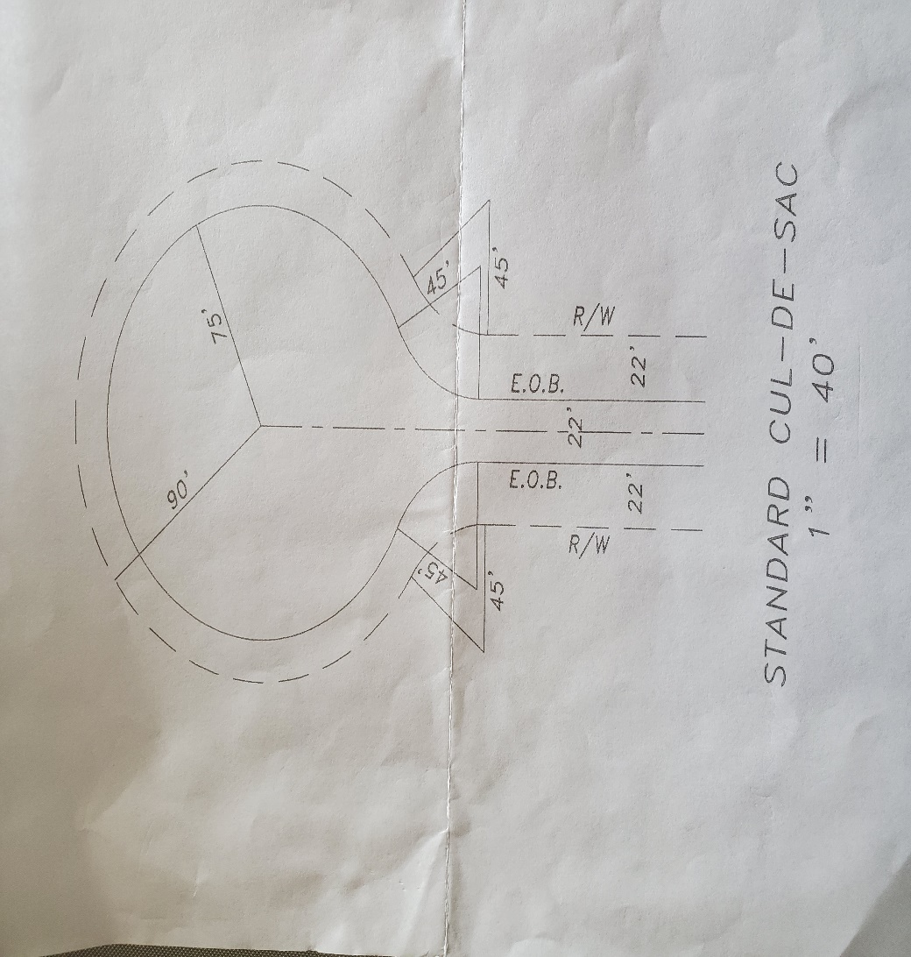
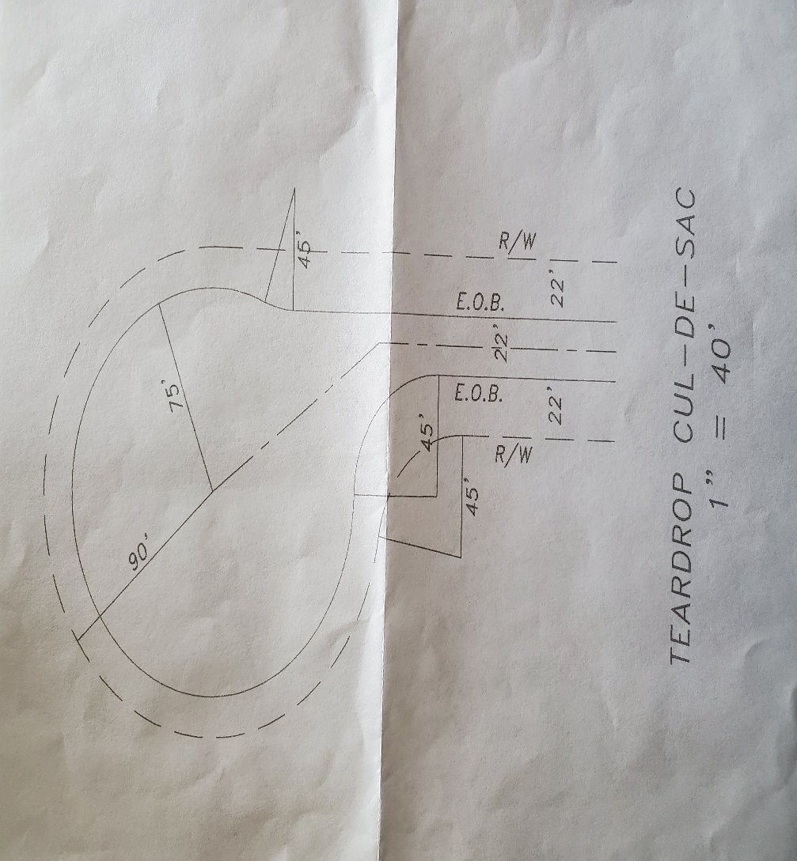

Appendix C
ROADS AND DRIVEWAYS
TOWN OF RED CEDAR
DUNN COUNTY, WISCONSIN

Typical Sections for Two Lane Rural Highways*
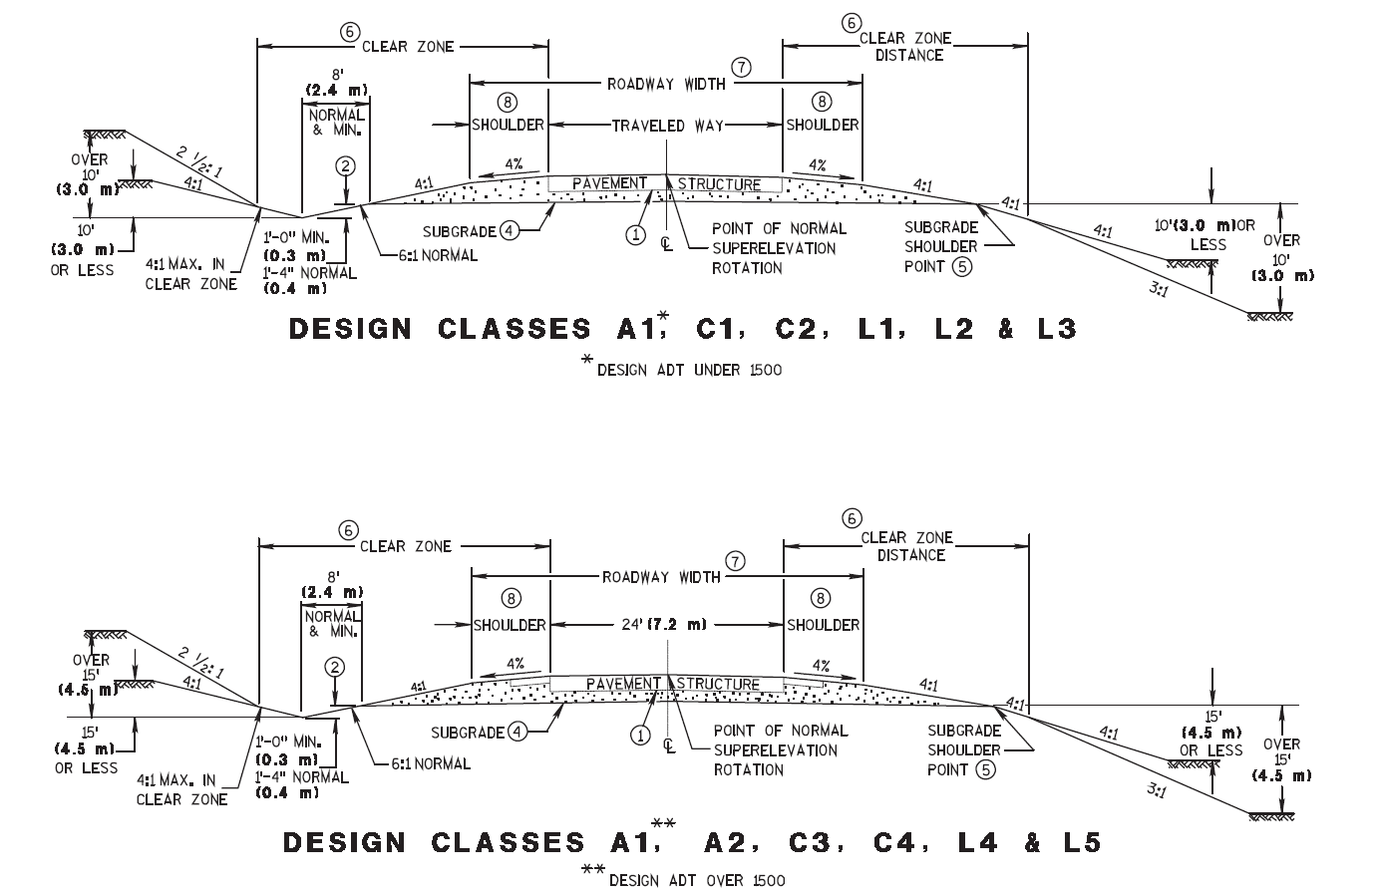

*Note: These diagrams are from the Wisconsin Department of Transportation Facilities Development Manual, FDM 11-15 Attachment 1.6 Typical Cross Sections for Rural 2-Lane Highways, and are incorporated by reference, including any amendments.

APPENDIX D
ROADS AND DRIVEWAYS
TOWN OF RED CEDAR
DUNN COUNTY, WISCONSIN
TOWN ACCEPTANCE/REJECTION OF NEW TOWN ROAD/ENGINEER CERTIFICATION
Engineer’s Report: The undersigned registered, professional engineer for the Town of Red Cedar hereby certifies that s/he has inspected the Town roads being recommended herein for acceptance and that the road recommended for Town acceptance have been constructed in substantial compliance with the approved plans and Town ordinances. All of the roads in the ________________________ subdivision for which the developer has requested Town acceptance were inspected on _________20____, to verify developer compliance with the road construction and paving requirements set forth in the Town Road and Driveway Ordinance concerning the said subdivision and otherwise required by other applicable regulations or law.
(Strike one and fill in as applicable.)
1. Some/all of the said roads are ready to be formally accepted by the Town Board in accordance with the terms of the Town Road and Driveway Ordinance. Roads recommended for acceptance.
2. Some/all of the roads are being rejected. The reason(s) for the rejection is/are
_______________________________________________________________________________
_______________________________________________________________________________
For the roads to be accepted, the following must occur:
________________________________________________________________________________
________________________________________________________________________________
Name of road(s) being rejected:
________________________________________________________________________________
_________________________________________________________________________________
(Note: Notice of acceptance or rejection shall be provided to the developer within fourteen (14) days of road inspection).
_________________________________________________
Engineer Date
Engineer recommendation approved and recommended for ratification by the Town Board:
_________________________________________________
Town Chair Date

APPENDIX D (CONTINUED)

The Town Board of Red Cedar, at its meeting on ________________________, 20____, voted to accept the dedication to the public of roads described herein and/or to deny acceptance of those roads designated herein for the reasons stated in the Engineer’s Report portion of this document.
NOTWITHSTANDING THE ACCEPTANCE HEREIN OF ANY TOWN ROADS, developers shall remain responsible for repairs to the accepted Town roads described herein through one full year from the date of acceptance.
Attest: ___________________________________________
Town Clerk Date

APPENDIX E
ROADS AND DRIVEWAYS
TOWN OF RED CEDAR
DUNN COUNTY, WISCONSIN

TOWN ROAD (CONSTRUCTION) PERMIT APPLICATION

(Current Permit Application and instructions are attached)

PERMIT NO: _______________________ Town of Red Cedar • Dunn County, Wisconsin
(Format: Year-No. – Ex. 2015-01, etc.) E6591 627th Avenue, Menomonie, WI 54751
Chairman - (715) 556-2244 • Clerk – (715) 556-5034
Email - clerktownofredcedar@gmail.com • Website – townofredcedar.com

It is unlawful to commence work before the Town of Red Cedar Chairman or designee approves this

Application and a Town Road (Construction) Permit is placed in a conspicuous location next to the proposed road.

TOWN ROAD (Construction) PERMIT APPLICATION

Applicant Road to which this road will connect

Name ___________________________ Road Name _________________________________

Address _________________________ in Subdivision Name ______________________

City ____________________________

Zip _______________

Phone ______________________ Expected completion date: (mo/year) _____ / _____

**** PLEASE PLACE VISIBLE STAKES AT THE DESIRED LOCATION FOR OUR INSPECTION****

Location of Connection Point of New Road to an Existing Road

________Side of the road ______ ________ ________of ______________________________

(N,S,E,W) # (miles/feet) (N,S,E,W) (reference point, i.e. intersection, etc.)

Description of proposed work (include special restrictions, intersection clearances, other details, and reference to any sketches which may be attached). Attach site plan to applications showing parcel size and proposed road with cross section of road.

I have read and agree to abide by the general requirements and conditions of this permit. I understand that the construction of the road is my responsibility and that it must be constructed in accordance with all requirements and any special conditions stated in the most recently adopted Town of Red Cedar, Dunn County, Town Road and Driveway Ordinance. I further understand that the maintenance of the road shall be my responsibility until the road has been formally accepted, in writing, by the Town Board as per the current Town Road and Driveway Ordinance. I understand that construction of a road without a permit in any manner which does not comply with the permit issued shall result in a fine and/or removal of the road. Damage to any connecting roadway or traveling through or depositing material in the ditch (road right-of-way) shall result in a fine plus costs of repairs.

________________________________________________ ___________________________________________

Signature of Applicant Date

NOTE TO DEVELOPERS: This permit application must be included as part of

the Town’s required Developer’s Agreement.

Town Road Construction General Requirements/Conditions

All new town roads (or any changes to existing Town Roads) require a Town Road Permit. [See Town Fee Schedule.]

Requirements
- A permit fee is due upon filing the Town Road Permit Application. Make checks payable to “Town of Red Cedar.” The Town Road Permit is good for two (2) years.
- Prior to opening the road to the public, the road must meet all requirements of this application, must meet Town Road standards, and must be inspected by the Town Board or their designated inspector.
- The permittee shall furnish all materials, do all work, and pay all costs in connection with the construction of the road and its appurtenances on the Town Road right of way. Until the Town Board accepts the road in writing, the subsequent maintenance of the road and its appurtenances within the limits of the Town Road right of way shall be the responsibility of the permittee, who shall be obligated to pay all costs and accomplish all works necessary in relation to the said maintenance of the road. Materials used and the type and character of the work shall be suitable and appropriate for the intended purpose. (See Town of Red Cedar Town Road and Driveway Ordinance for specific requirements.)
- No revisions or additions shall be made to the road or its appurtenances on the right of way without the written permission of the Town Board.
- The Town of Red Cedar reserves the right to make such changes, additions, repairs and relocations within statutory limits to the road or its appurtenances on the right of way as may at any time be considered necessary to facilitate the relocation, reconstruction, widening and maintaining of a Town Road, or to provide proper protection to life and property on or adjacent to the road.
- The permittee, his successors or assigns agree to hold harmless the Town of Red Cedar and its duly appointed agents and employees against any action for personal injury or property damage sustained by reason of the exercise of this permit.
- The Town of Red Cedar does not assume any responsibility for the removal or clearance of snow, ice or sleet, or the opening of windrows of such material, upon any portion of any road that has not been accepted in writing by the Town Board, even though snow, ice or sleet is deposited or windrowed on said road by its authorized representatives engaged in normal winter maintenance operation.
- The permittee must notify the Town Board or the designated inspector within 30 days of road completion.
- See most recently adopted Town Road and Driveway Ordinance for a complete listing of requirements and permitted exceptions.

Conditions
- Cement trucks, building supply trucks, and landscaping vehicles will not drive through the road ditches.
- All washing of trucks and deposition of excess concrete will be done on the property, not in the road right of way.
- The road ditches shall not be filled without prior approval by the Town.

To be Completed by Town Any restrictions to access? YES – NO

Drainage Structure Required? YES – NO If yes: Diameter _____ Length _____ Material ______________________

Other / Comments: __________________________________________________________________________________

APPROVED BY

_____________________________________________ __________________ Approval Expires _____________________

Town Chairman or Designee Date

FINAL INSPECTION

_____________________________________________ __________________

Town Chairman or Designee Date

